***DATABASE PROJECT***

**Faculty: Kawser Irom Rushee**

**Topic: Railway Reservation System**

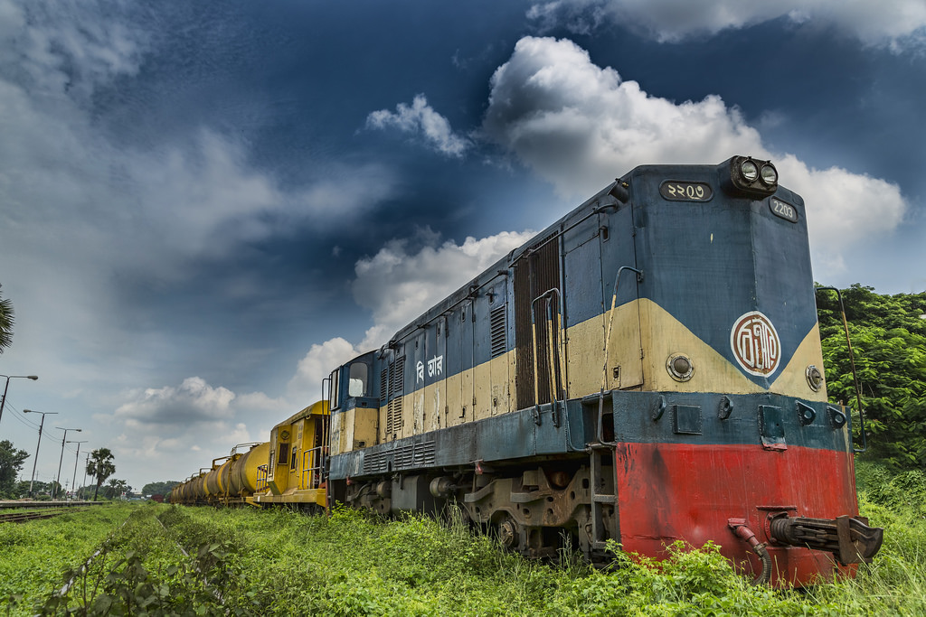

|  |  |  |  |
| --- | --- | --- | --- |
| **No** | **Name** | **ID** | **Signature** |
| 1 | Rahman, Md Samiur | 16-31883-1 |  |
| 2 | Hasan, Md Sajid | 15-29818-2 |  |
| 3 | Mosaddeq Shadman | 15-30748-3 |  |
| 4 |  |  |  |
| 5 |  |  |  |
| 6 |  |  |  |